White Pine Consulting Service
206 North Main Street, Suite B
Waupaca, WI 54981
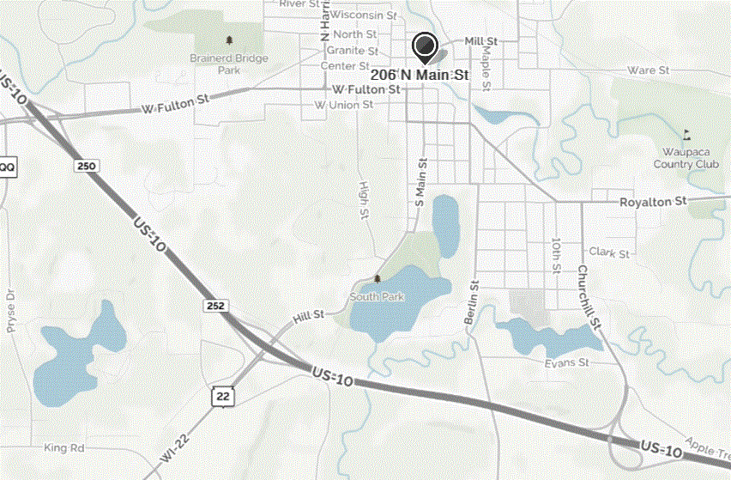
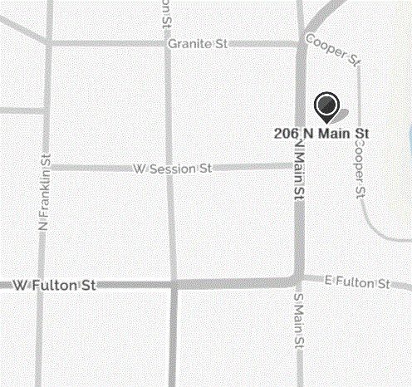
office: (715) 258-0877
Traveling north, 206 North Main Street is the last unit/building on Main Street before the Firehouse Apartments.

Parking and Entrances:
- Cooper Street: There is unlimited parking on Cooper Street which takes you down behind Main Street (follow signs for Rotary Riverview Park). Immediately past the apartment building is a building with a blue awning and blue door. Use this entrance; White Pine is at the top of the first flight of stairs.
- Main Street: There is 2-hour parking on Main Street. Use the entrance for the “Valley Packaging”. Follow the short hallway and turn left, and take the steps to the lower level.

N

